
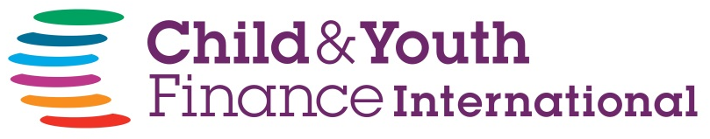

proudly certifies that

……………………………………………………..

for their participation in the Global Money Week 2015 Celebrations.

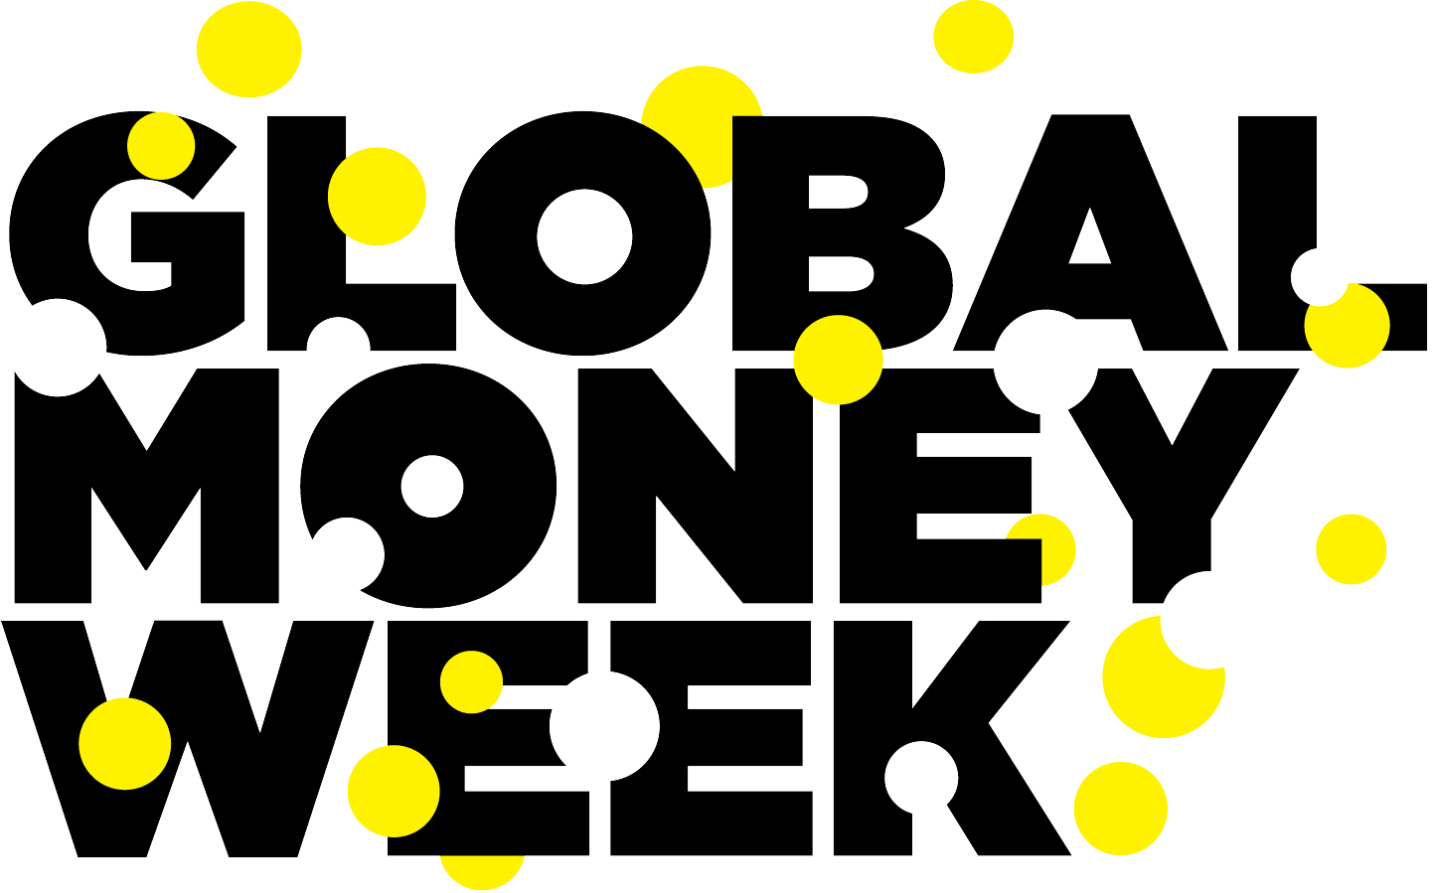

Global Money Week encourages children around the world to unite their voices, take action and expand their knowledge and engagement with the financial issues that matter most to them. Through national and international events, youngsters learn about creating livelihoods, gaining employment and even starting their own businesses. They become financially empowered, make their own choices, create their own livelihoods, and prevent or break the cycle of poverty.

To learn more, visit our website at:
www.childfinanceinternational.org
www.globalmoneyweek.org

