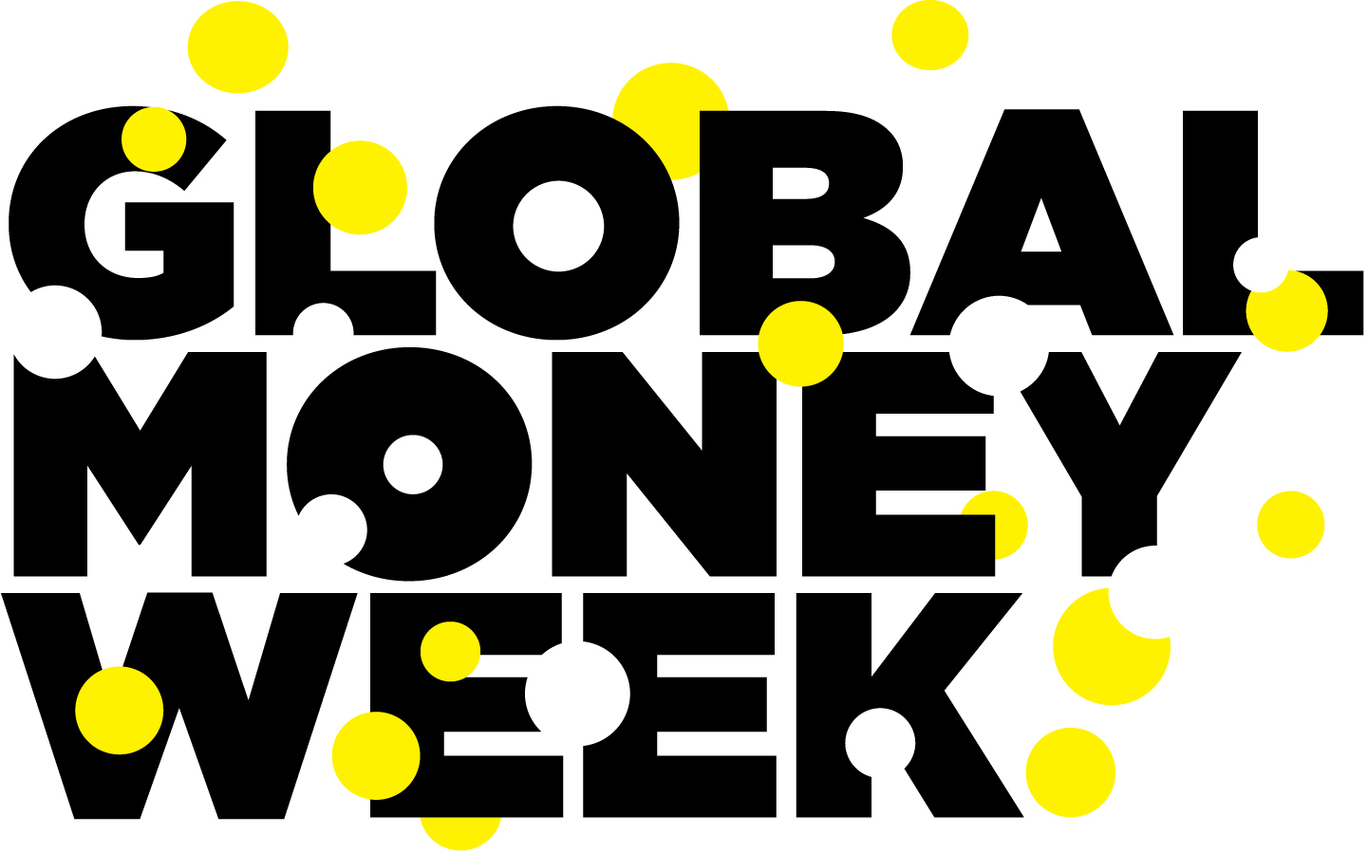

The best thing about Global Money Week is..

