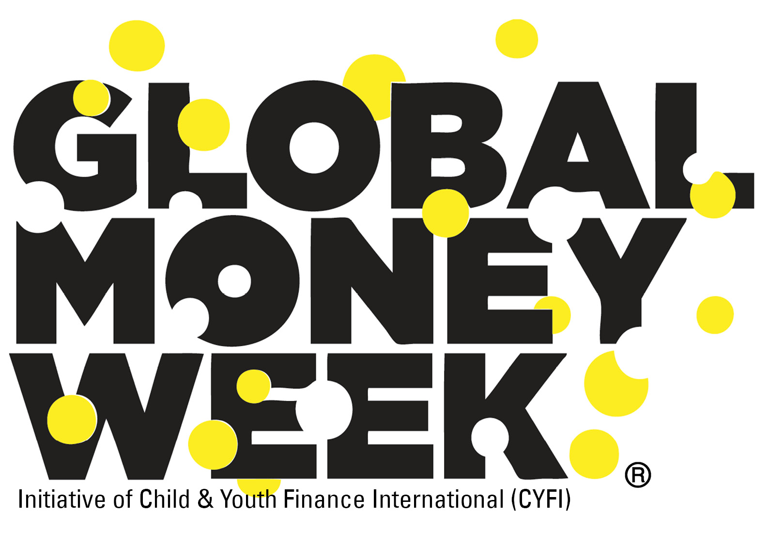
CERTIFICATE OF PARTICIPATION

Is hereby proudly awarded to

……………………………………………………………………

for participating in the Global Money Week 2018 Celebrations

______________________________________________________________________

Global Money Week (GMW), an initiative of CYFI, is an annual money awareness campaign with local and regional events and activities aimed at inspiring children and youth to learn about money, saving, creating livelihoods, gaining employment and becoming an entrepreneur.

#GMW2018 #GlobalMoneyWeek #MoneyMatters Matter www.globalmoneyweek.org

